# 7. Sass Operator – I:

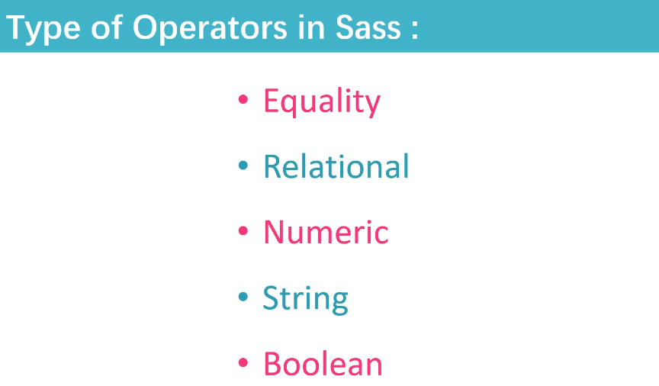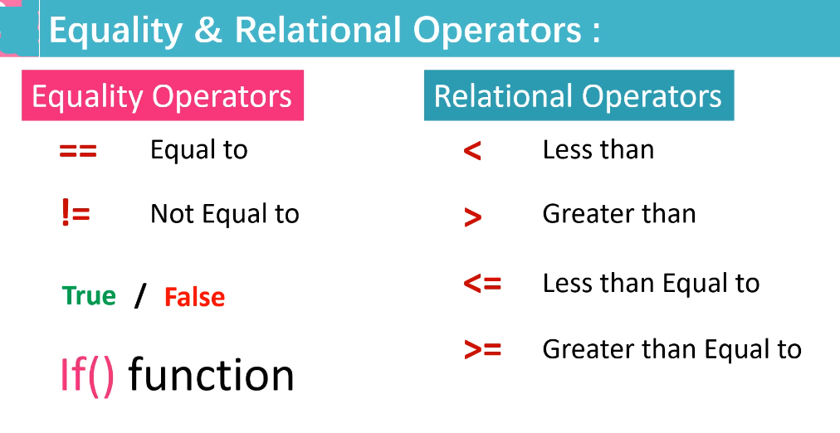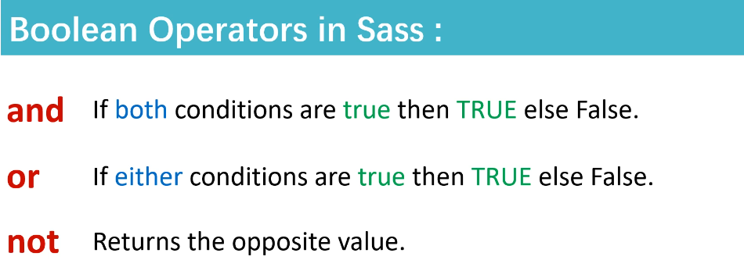

**True / False use with:** if ( ) condition

**and Ex.** Condition1 and Condition2

10px == 10px and arial == “arial”

**or Ex.** Condition1 or Condition2

10px == 20px or arial == “arial”